Sprint Plan 1

Marine Plastics Monitor

Marine Plastics Team

1/29/18

**Goal**: To learn the necessary requirements to build a template and format for the web application.

**User Story 1: As an engineer I want to be able to learn ReactJS and MongoDB in order to implement an organized and functional website. 5**

Task 1: Follow the tutorials so we understand ReactJS and MongoDB: 5

* <https://reactjs.org/tutorial/tutorial.html>
* <https://www.youtube.com/watch?v=A71aqufiNtQ&ab_channel=TraversyMedia>
* <https://www.codecademy.com/learn/react-101>
* <https://getuikit.com/docs/introduction>
* <https://semantic-ui.com/introduction/getting-started.html>
* <https://www.youtube.com/watch?v=pWbMrx5rVBE>

**User Story 2: As a member of Clean Oceans I want a clean, organized, and planned layout of the website so I can easily find the necessary links. 8**Task 1: Make a clean landing page 2

Task 2: Create a template that will serve as a basis for the website 2

Task 3: Create a navigation bar 1

Task 4: Creating a basis form for the data (not connected to the database) 3

Task 5: Create a page that will display the necessary data 2

Task 6: Create a page that will display the protocol and have the necessary photos and 3

data to educate the public

**Initial burnup chart:**

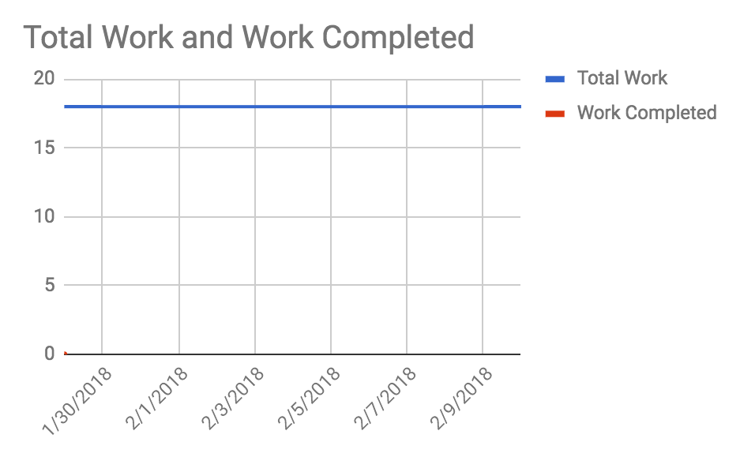

**Scrum Board:**

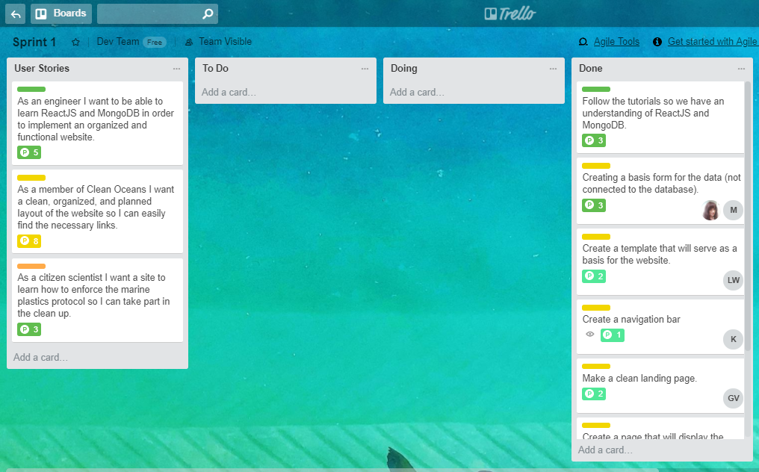

**Scrum times**:

Mondays @ 3:30

Thursday @ 10:10

Saturdays @ 11

TA Meeting: Thursday @ 10:30